# **33. IPv6 : PART 3**

## **CORRECTION TO PRIOR LECTURES:**

### **RFC Requirements for IPv6 Address Representation**

* **Leading 0s MUST be removed**
  + Example:
    - 2001:0db8:0000:0001:0f2a:4fff:fea3:00b1
    - Becomes: 2001:db8:0:1:f2a:4fff:fea3:b1
* **:: MUST be used to shorten the longest string of all-0 quartets**
  + If there is only **ONE** all-0 quartet, don’t use ::.
  + Example:
    - 2001:0000:0000:0000:0f2a:0000:0000:00b1
    - Becomes: 2001::f2a:0:0:b1
* **If there are two equal-length choices for ::, use :: to shorten the leftmost one**
  + Example:
    - 2001:0db8:0000:0000:0f2a:0000:0000:00b1
    - Becomes: 2001:db8::f2a:0:0:b1
* **Hexadecimal characters (a-f) MUST be written in lowercase**

## **IPv6 HEADER**

**Length:** Always **40 bytes** (Fixed Header)

### **Fields:**

* **Version (4 bits):** Indicates the IP version in use (always 6).
* **Traffic Class (8 bits):** Used for **QoS** (e.g., prioritizing VoIP, video calls, etc.).
* **Flow Label (20 bits):** Identifies traffic **flows** between source and destination.
* **Payload Length (16 bits):** Length of the **Layer 4 encapsulated segment** (excluding the IPv6 header).
* **Next Header (8 bits):** Identifies the **next header type** (e.g., TCP, UDP).
* **Hop Limit (8 bits):** Similar to IPv4 TTL; decrements by 1 at each router hop.
* **Source Address (128 bits):** Originating node's IPv6 address.
* **Destination Address (128 bits):** Receiving node's IPv6 address.

## **SOLICITED-NODE MULTICAST ADDRESS**

* A **Solicited-Node Multicast Address** is generated from a **Unicast Address**.
* This address is used for **Neighbor Discovery Protocol (NDP)**.
* Automatically joined by interfaces with an IPv6 address.
* Ff02::1:ff + last 6 hex digits of unicast address

## **NEIGHBOR DISCOVERY PROTOCOL (NDP)**

* **Neighbor Discovery Protocol (NDP)** replaces **ARP** in IPv6.
* Uses **ICMPv6** messages instead of **broadcasts**.

### **Two Key Messages for MAC Address Resolution:**

1. **Neighbor Solicitation (NS)**
   * ICMPv6 Type **135**
2. **Neighbor Advertisement (NA)**
   * ICMPv6 Type **136**

### **Router Discovery:**

* **Router Solicitation (RS)**
  + ICMPv6 Type **133**
  + Sent to FF02::2 (All Routers) to request router information.
* **Router Advertisement (RA)**
  + ICMPv6 Type **134**
  + Sent to FF02::1 (All Nodes) to announce router presence and network parameters.

## **STATELESS ADDRESS AUTO-CONFIGURATION (SLAAC)**

* SLAAC allows hosts to **auto-generate** an IPv6 address.
* Uses **RS/RA messages** to learn the local network prefix.
* Address generation methods:
  + **EUI-64**: Uses part of the device's MAC address.
  + **Randomly generated** (depends on the OS and configuration).

### **Configuration Commands:**

**Manual Prefix Input:** R2(config-if)# ipv6 address prefix / prefix-length eui-64

**Automatic Prefix Learning:** R2(config-if)# ipv6 address autoconfig

## **DUPLICATE ADDRESS DETECTION (DAD)**

* Ensures that an IPv6 address is **not already in use**.
* Uses **Neighbor Solicitation (NS) and Neighbor Advertisement (NA)** messages.
* Process:
  + The host sends an **NS to its own address**.
  + If **no reply**, the address is unique.
  + If **reply received**, another host is using the address.

## **IPv6 STATIC ROUTING**

* IPv6 routing functions **separately** from IPv4.

IPv6 routing is **disabled by default** and must be enabled:  
R2(config)# ipv6 unicast-routing

* If IPv6 routing is **disabled**, the router can send/receive IPv6 traffic but **won’t forward it**.

### **Static Routing Types:**

**Directly Attached Static Route** (Exit Interface Specified)  
  
 ipv6 route destination/prefix-length exit-interface

**Example:** R1(config)# ipv6 route 2001:db8:0:3::/64 g0/0

**Note:** Cannot use this for **Ethernet interfaces**.

**Recursive Static Route** (Next-Hop Specified)  
  
 ipv6 route destination/prefix-length next-hop

**Example:** R1(config)# ipv6 route 2001:db8:0:3::/64 2001:db8:0:12::2

**Fully Specified Static Route** (Exit Interface & Next-Hop)  
  
 ipv6 route destination/prefix-length exit-interface next-hop

**Example:** R1(config)# ipv6 route 2001:db8:0:3::/64 g0/0 2001:db8:0:12::2

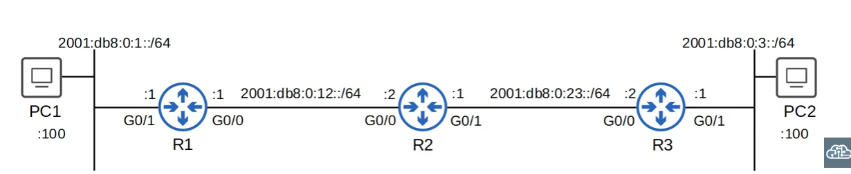**Network Route** R1(config)# ipv6 route 2001:db8:0::/64 2001:db8:0:12::2

* + Routes to R3/PC2 network via R2’s g0/0 interface.

**Host Route** (/128 Prefix for a Specific Address)  
  
 R2(config)# ipv6 route 2001:db8:0:1::100/128 2001:db8:0:12::1

* + Used for **specific IPv6 addresses**.

**Default Route** (::/0 equivalent to 0.0.0.0/0 in IPv4)  
  
 R3(config)# ipv6 route ::/0 2001:db8:0:23::1

**Floating Static Routes**

* + Used as a **backup route** with a higher **Administrative Distance (AD)**.

**Link-Local Next Hops**

* + **Must specify the exit interface** along with the link-local address.

This concludes **IPv6 Part 3**, covering **address representation, header structure, NDP, SLAAC, DAD, and static routing**.